The Woman who is mentoring me works in the Heliophysics department at NASA.

**Monday**

Mapping the dark Aurora lights using MATLAB

**Tuesday**

Mapping the dark Aurora lights using MATLAB

**Wednesday**

Mapping the dark Aurora lights using MATLAB

Reliazed it was doing to much to slowly and researched for a different route to faster ananlyze the video

Recursive Particle Tracking

<https://www.youtube.com/watch?v=Y_xlB94z8c0>

**Thursday**

Mapping the dark Aurora lights using MATLAB

**Friday**

Mapping the dark Aurora lights using MATLAB

**Project 1 -Talk Machines Mechanisms**

**Same amount of progress done since before. Mainly research more info on the other stuff has began.**

**Project 2 - MATLAB Aurora Lights**

**I continued on ward with the first attempt at this problem. It seemed a lot easier but and simple. The main issue in me changing any way to optimize the speed of the whole process but it seemed to workout to be the same amount with the particle solution with added obstacles that seemed to undermine the me doing it this way. In other words the effort put in seemed to high for what I was trying to get out.**

**So after doing the switch back instead of speed I found myself trying to work on the sizing issue. I tried just reshaping the size of the crop square but the computer kept giving me a resizing error when I went to try and find a correlation with the Cov (X,Y) with x and y being the cropped image and the original image. I kept getting the error because I was essentially trying to compare the different sized picture which to the computer reads it as an array of numbers that where different sizes. And in Matlab your cant really compare arrays to one anther if they are of different size.**

**The problem came up because I forgot that, what I was actually doing was making the cropped image relative to the size of the base image. What ever the size of the base image the code would crop a piece of the larger image that exact size and compare those to.**

**So the solution to this problem was actually simpler than it needed to be. I didn’t realize it till I saw the issue but snice the code is making cropped images relative to the size of the base image it just makes more sense to go in and make the base image a lot smaller. Literally taking smaller snippets of the image was the answer. And it worked pretty well since I found the same areas pretty much as well as the similar areas.**

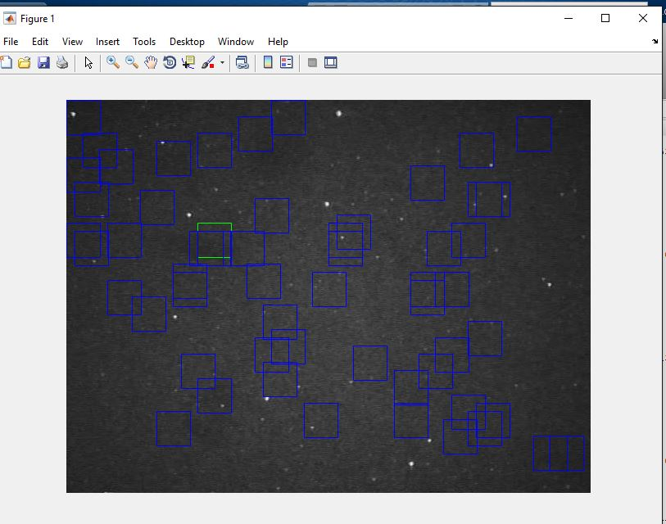

**(room for improvement and a better threshold but it’s a pretty similar as with the big boxes)**